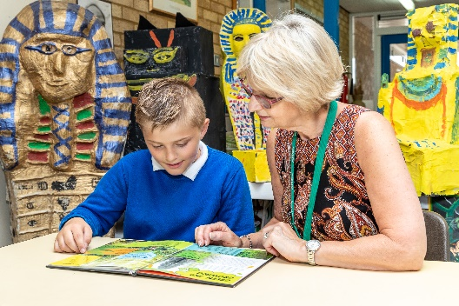
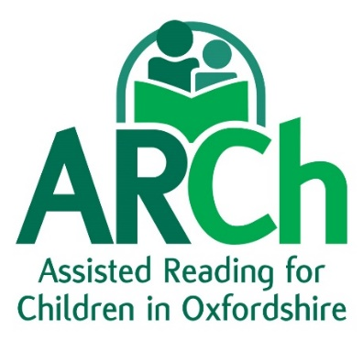
Opportunity to train as an ARCh Reading Helper
ARCh volunteers work one to one with selected children in a primary school, close to their home or workplace, providing personalised support to boost confidence, build self-esteem and turn around negative attitudes to reading.
We are looking for more people to join us in making a real difference to children’s lives.
All volunteers are interviewed by ARCh, receive enhanced DBS checks and receive initial and ongoing training and support as well as resources tailored to each child.
If you would like to get involved as a volunteer or supporter, or if you work in a school and are interested in our service, please email info@archoxfordshire.org.uk
Please support us – you can donate via https://localgiving.org/donation/arch
Registered Charity number 1146276 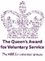 Company number 7962217

ARCh is committed to Safeguarding and this role is exempt from ROA 1974 and eligible for enhanced DBS certificate/barred list check

